Blossom Watch 2021

Alan Millington

2021-03-24 14:15:42

This table shows the total count of hashtags used where the various combinations are used by twitter users. When the tweet does not contain a hashtag, but contains the keywords it falls into the ‘no hashtag’ group. If any new hashtags are required to be tracked, please let me know and this can be easily updated.

|  |  |
| --- | --- |
| hashtag | count |
| blossom | 2572 |
| blossomwatch | 1658 |
| NationalTrust + BlossomWatch | 37 |
| EveryoneNeedsNature | 320 |
| No Hashtag (Text contains keywords) | 1843 |

# Timeline

## Tweets by day

Frequency of tweets broken down by day. 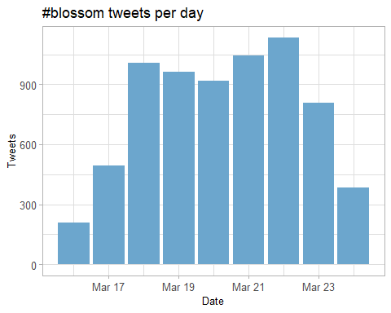

## Tweets by day and time

Filtered for dates March, London time. Tweet frequency broken down by day and hour of day. 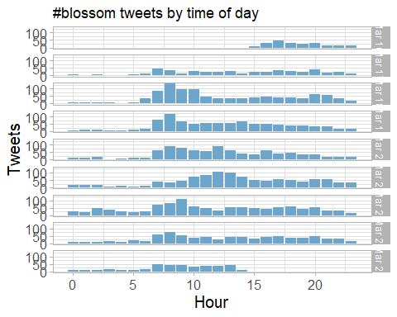

# Users

## Top tweeters

Top twitter users that have tweeted more than 10 tweets containing the #blossom hashtag. 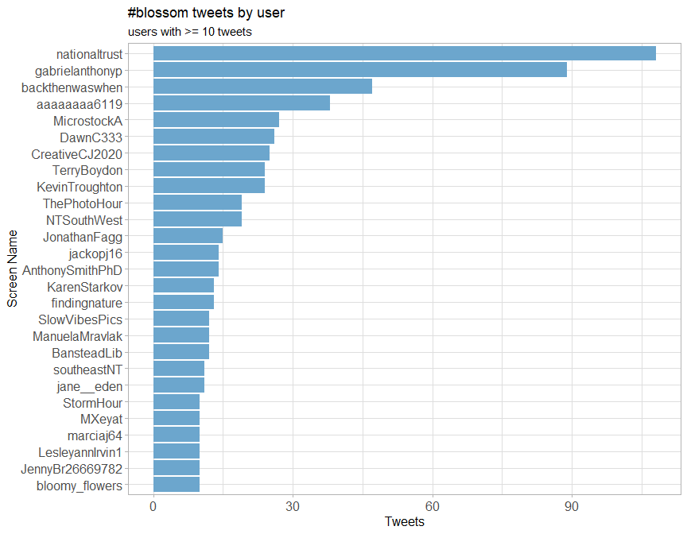

## Sources

Breakdown of twitter source clients that have used the #blossom hashtag. 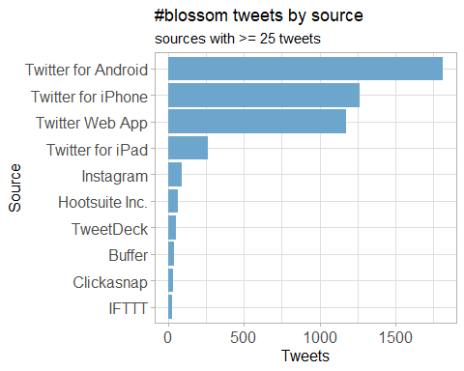

## Network Replies

The “replies network”, composed from users who reply directly to one another where the hashtag or keyword of blossom was part of the message text. Complied on Friday 19th March.



## Network Mentions

The “mentions network” is where users mention other users in their tweets and those tweets contain a keyword such as blossom. The large network (mid-right) is the National Trust twitter account. The smaller networks are key influencers that have shared blossom tweets with their network which have subsequently shared it to their followers too.



# Retweets

## Top retweets

Top re-tweeters and total re-tweet counts.

|  |  |  |
| --- | --- | --- |
| screen_name | text | retweet_count |
| nationaltrust | Pause to soak up the sweet scents and soft songs emanating from blossom branches. These colourful trees are a feast for the senses. #BlossomWatch <https://t.co/GsXfF5KPAE> | 243 |
| DrDarrenRFlower | Central Park New York #spring #spring2021 #blossom #cherry <https://t.co/Oimq2hRU1k> | 152 |
| nationaltrust | Happily dancing in the breeze, a golden daffodil is full of cheer. #EveryoneNeedsNature <https://t.co/hSOWdCCnPL> | 122 |
| nationaltrust | Everywhere these delicate flowers emerge, they bring delight with them. Thanks to everyone who’s helped spread the joys of blossom so far - keep the photos coming with #BlossomWatch. Photos: Joanna A, Catherine A, Shonali B, Cara W. <https://t.co/6znNDEdvKC> | 122 |
| nationaltrust | <U+0001F338>#BlossomWatch<U+0001F338> Lockdowns have changed the nation’s relationship with nature for the better. We are feeling more connected thanks to our daily strolls and taking more notice of the changing seasons. <https://t.co/JtIkqgUorV> | 101 |
| MikeDoylePhotos | Autumnal view at Sheffield Park, East Sussex. #Sussex #England #NationalTrust #landscape #landscapephotography #travel #travelphotography #photo #photography #photooftheday #NaturePhotography <https://t.co/FqII3JWs8w> | 97 |
| nationaltrust | When you see the blossom dancing in the breeze, pause to notice the bewitching perfume drifting along with it. #BlossomWatch <https://t.co/Kh68Hh3iMx> | 78 |
| nationaltrust | One of life’s simple pleasures that can be enjoyed from anywhere. Engross yourself in the calming colours of a sunrise. #EveryoneNeedsNature <https://t.co/l5xkDICUPn> | 72 |
| ampomata | This is my new painting “Bed Of Roses”. You can check it out here: <https://t.co/GoYnqeM1YY> #art #arte #oleo #kunst #oilpainting #contemporaryart #ArtistOnTwitter #blossom #flower #floral #spring #pink #red #roses #field #artprints #flowers #garden <https://t.co/7y9skbUaMs> | 69 |
| MikeDoylePhotos | Early autumn at Sheffield Park, East Sussex. #Sussex #England #NationalTrust #landscape #landscapephotography #travel #travelphotography #photo #photography #photooftheday #NaturePhotography <https://t.co/fqSC6f0xMQ> | 64 |

# Favourites

## Favourite proportion

How many times a tweet was saved a favourite that contained the blossom keywords. 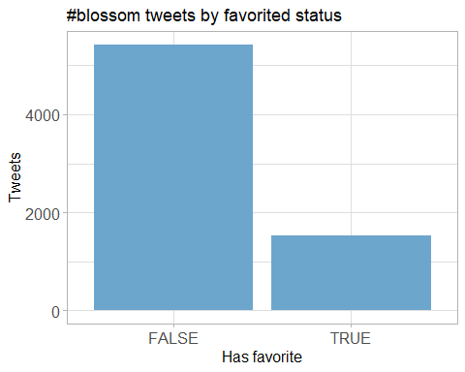

## Top favourites

|  |  |  |
| --- | --- | --- |
| screen_name | text | favorite_count |
| nationaltrust | Pause to soak up the sweet scents and soft songs emanating from blossom branches. These colourful trees are a feast for the senses. #BlossomWatch <https://t.co/GsXfF5KPAE> | 1127 |
| DrDarrenRFlower | Central Park New York #spring #spring2021 #blossom #cherry <https://t.co/Oimq2hRU1k> | 836 |
| nationaltrust | Everywhere these delicate flowers emerge, they bring delight with them. Thanks to everyone who’s helped spread the joys of blossom so far - keep the photos coming with #BlossomWatch. Photos: Joanna A, Catherine A, Shonali B, Cara W. <https://t.co/6znNDEdvKC> | 697 |
| nationaltrust | Happily dancing in the breeze, a golden daffodil is full of cheer. #EveryoneNeedsNature <https://t.co/hSOWdCCnPL> | 691 |
| MikeDoylePhotos | Autumnal view at Sheffield Park, East Sussex. #Sussex #England #NationalTrust #landscape #landscapephotography #travel #travelphotography #photo #photography #photooftheday #NaturePhotography <https://t.co/FqII3JWs8w> | 641 |
| nationaltrust | <U+0001F338>#BlossomWatch<U+0001F338> Lockdowns have changed the nation’s relationship with nature for the better. We are feeling more connected thanks to our daily strolls and taking more notice of the changing seasons. <https://t.co/JtIkqgUorV> | 600 |
| MikeDoylePhotos | Early autumn at Sheffield Park, East Sussex. #Sussex #England #NationalTrust #landscape #landscapephotography #travel #travelphotography #photo #photography #photooftheday #NaturePhotography <https://t.co/fqSC6f0xMQ> | 546 |
| nationaltrust | Who else is buzzing with excitement at the blossom appearing? We love hearing the calming hum of bees enjoying the flowers. #BlossomWatch Photo: Rosie S, @ClivedenNT <https://t.co/JGcihvsoCV> | 536 |
| JuliaBradbury | Spending time to dwell on nature can improve your wellbeing- research shows that just 20 mins can improve your mood.Only 6% take the time to celebrate things like the first seasonal first day of spring. @nationaltrust is helping to plant more blossom trees #BlossomWatch #hanami <https://t.co/UkuU9I6x91> | 527 |
| nationaltrust | When you see the blossom dancing in the breeze, pause to notice the bewitching perfume drifting along with it. #BlossomWatch <https://t.co/Kh68Hh3iMx> | 455 |

# Quotes

## Top quotes

|  |  |  |
| --- | --- | --- |
| screen_name | text | quote_count |
| eastdevon | #BlossomWatch campaign: @nationaltrust invites us to share and celebrate blossom to spread the joy of spring. Take a moment on your daily exercise to look for birds, butterflies or bees on blossom trees near your home. Shared by #EDDChealth <https://t.co/GyqfHL921h> | 5 |
| Ms_SJP | Well the National Trust’s #blossomwatch hashtag is my new favourite thing, I have to say! <U+0001F338> <https://t.co/i4cj9FF1VX> | 5 |
| LBGAmbEast | Some wonderful images on @nationaltrust’s #BlossomWatch thread <https://t.co/1XSkaKnQZc> | 5 |
| NaturalEngland | Our research shows that nature is more important than ever to us since the pandemic started. We’re taking more notice of small changes in nature and signs of spring, like beautiful apple blossom. Share your pictures of blossom with @NationalTrust using <U+0001F338>#BlossomWatch <U+0001F338> <https://t.co/KlDTIYa46E> | 5 |
| radiowinch | Spring is on the way. Celebrate the arrival of blossom near you with #BlossomWatch share your photos <https://t.co/B0TuHmf6Sk> | 5 |
| LilianGreenwood | Lots of us are enjoying the signs of spring and taking photos on our daily walks, but until today I didnâ€™t realise that this was a thing with its own hashtag! #BlossomWatch <https://t.co/VvMiQTmKJu> | 3 |
| sheffieldparkNT | Here at @Nationaltrust we are celebrating the delicate clusters of flowers that are starting to appear on the trees- #blossomwatch is here! Have you spotted any blooms festooning the trees? Share your pics on our blossom map with #BlossomWatch <https://t.co/Uk6EYfJsV4> <https://t.co/T1QMKLUHwo> | 3 |
| LauraSkitt_ | I love blossom trees so much. It reminds me spring is nearly here which means my birthday is nearly here (end of April, but still!) #BlossomWatch <U+0001F338> <https://t.co/gB9yiEInEo> | 3 |
| JamesGardening | Share with everyone your blossom pics using the #BlossomWatch and national trust. plenty of amazing pictures to view. <https://t.co/57ZDpy4865> | 3 |
| SpiralStripeArt | Loving the @nationaltrust latest campaign #BlossomWatch which I know my #SMM friends will appreciate as a brilliant example of user-generated content! <U+0001F338> The campaign has even been advertised on <U+0001F4FA> @1OFFGINGER @sociallymaz @TechPixies @hellosocialLdn @muchmoresocial <https://t.co/EGyVKh0Vht> | 3 |

# Media

## Media count

Shows tweets where a piece of media was shared such as images or videos. 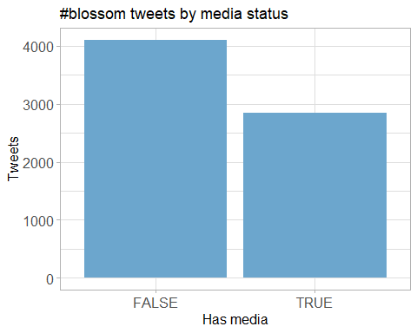

## Top media

|  |  |  |
| --- | --- | --- |
| screen_name | text | favorite_count |
| nationaltrust | Pause to soak up the sweet scents and soft songs emanating from blossom branches. These colourful trees are a feast for the senses. #BlossomWatch <https://t.co/GsXfF5KPAE> | 1127 |
| DrDarrenRFlower | Central Park New York #spring #spring2021 #blossom #cherry <https://t.co/Oimq2hRU1k> | 836 |
| nationaltrust | Everywhere these delicate flowers emerge, they bring delight with them. Thanks to everyone who’s helped spread the joys of blossom so far - keep the photos coming with #BlossomWatch. Photos: Joanna A, Catherine A, Shonali B, Cara W. <https://t.co/6znNDEdvKC> | 697 |
| nationaltrust | Happily dancing in the breeze, a golden daffodil is full of cheer. #EveryoneNeedsNature <https://t.co/hSOWdCCnPL> | 691 |
| MikeDoylePhotos | Autumnal view at Sheffield Park, East Sussex. #Sussex #England #NationalTrust #landscape #landscapephotography #travel #travelphotography #photo #photography #photooftheday #NaturePhotography <https://t.co/FqII3JWs8w> | 641 |
| nationaltrust | <U+0001F338>#BlossomWatch<U+0001F338> Lockdowns have changed the nation’s relationship with nature for the better. We are feeling more connected thanks to our daily strolls and taking more notice of the changing seasons. <https://t.co/JtIkqgUorV> | 600 |
| MikeDoylePhotos | Early autumn at Sheffield Park, East Sussex. #Sussex #England #NationalTrust #landscape #landscapephotography #travel #travelphotography #photo #photography #photooftheday #NaturePhotography <https://t.co/fqSC6f0xMQ> | 546 |
| nationaltrust | Who else is buzzing with excitement at the blossom appearing? We love hearing the calming hum of bees enjoying the flowers. #BlossomWatch Photo: Rosie S, @ClivedenNT <https://t.co/JGcihvsoCV> | 536 |
| JuliaBradbury | Spending time to dwell on nature can improve your wellbeing- research shows that just 20 mins can improve your mood.Only 6% take the time to celebrate things like the first seasonal first day of spring. @nationaltrust is helping to plant more blossom trees #BlossomWatch #hanami <https://t.co/UkuU9I6x91> | 527 |
| nationaltrust | When you see the blossom dancing in the breeze, pause to notice the bewitching perfume drifting along with it. #BlossomWatch <https://t.co/Kh68Hh3iMx> | 455 |

### Most liked media image

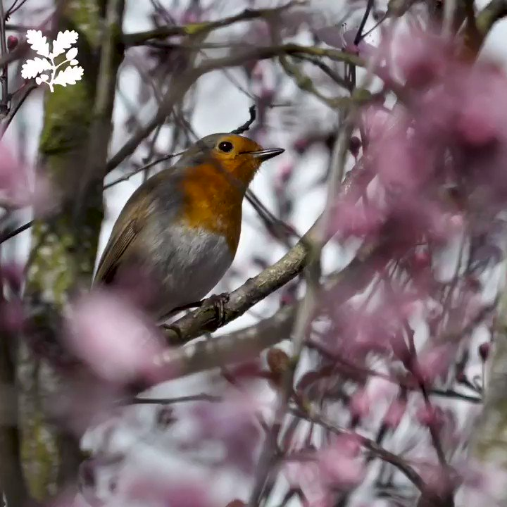

# Tweet text

The top 150 words used 3 or more times within tweet which contain keywords around blossom. Words removed: blossom, blossomwatch, nationaltrust, everyoneneedsnature.

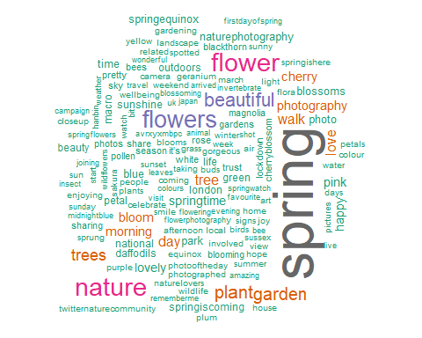

## Tweets by Tweet Length

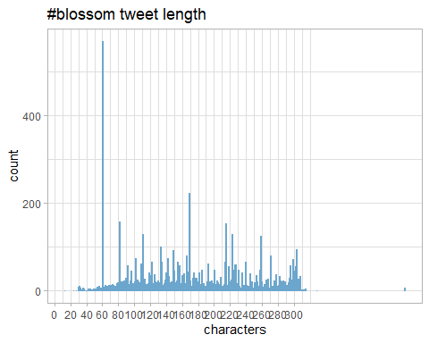

## Blossom Sentiment Analysis - Visualisation

This process analyses each word within the tweet and then categorises the tweet into one of 8 main categories and polarity. Each triangle in the plot is a tweet where one of the blossom keywords was found and the overall tweet was categorised. Blossom related tweets show strong ‘positive’ and ‘joy’ correlations based on the language used by tweeters. 